**Metal-Oxide Semiconductor Field Effect Transistor (MOSFET)**

MOSFET is widely used in electronic circuits because of its

* Low power consumption
* Small footprint
* Easy and inexpensive manufacture

It is gradually superseding the BJT.

**Types:**

Two types: NMOS and PMOS

**Structure:**

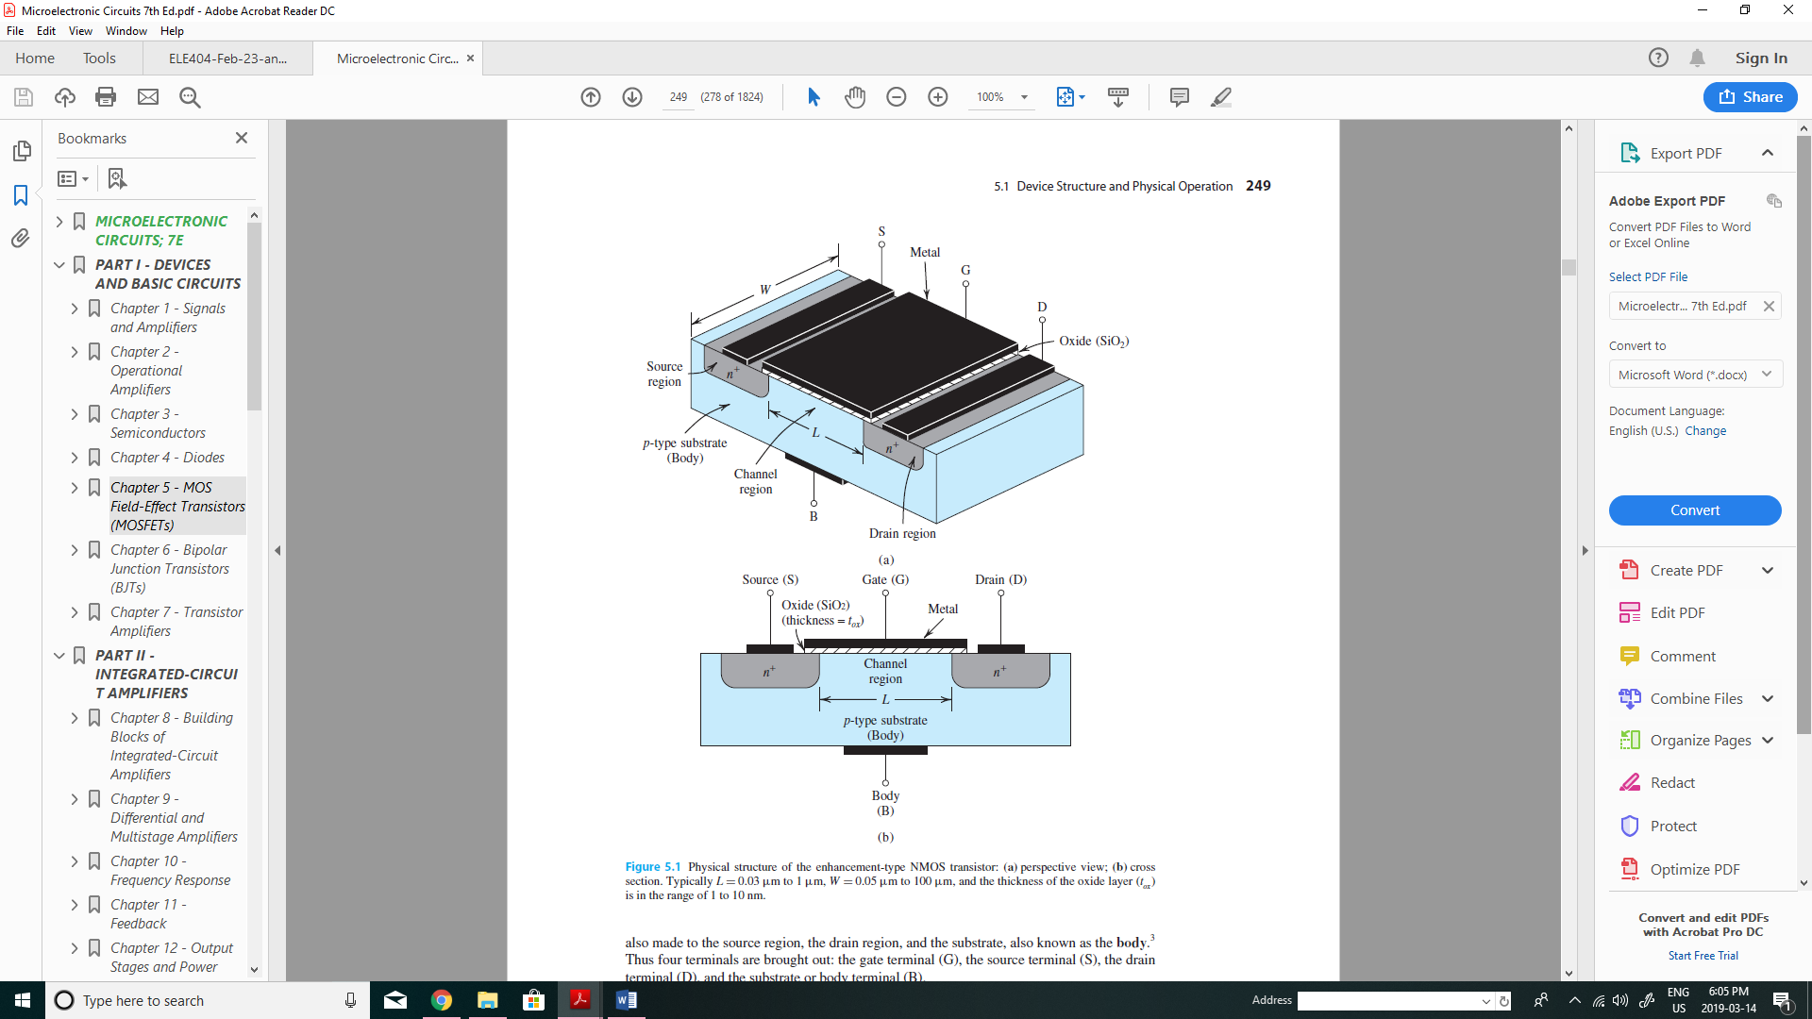

Figure: Physical structure of an NMOS device



Figure: Cross-sectional diagram of an NMOS device

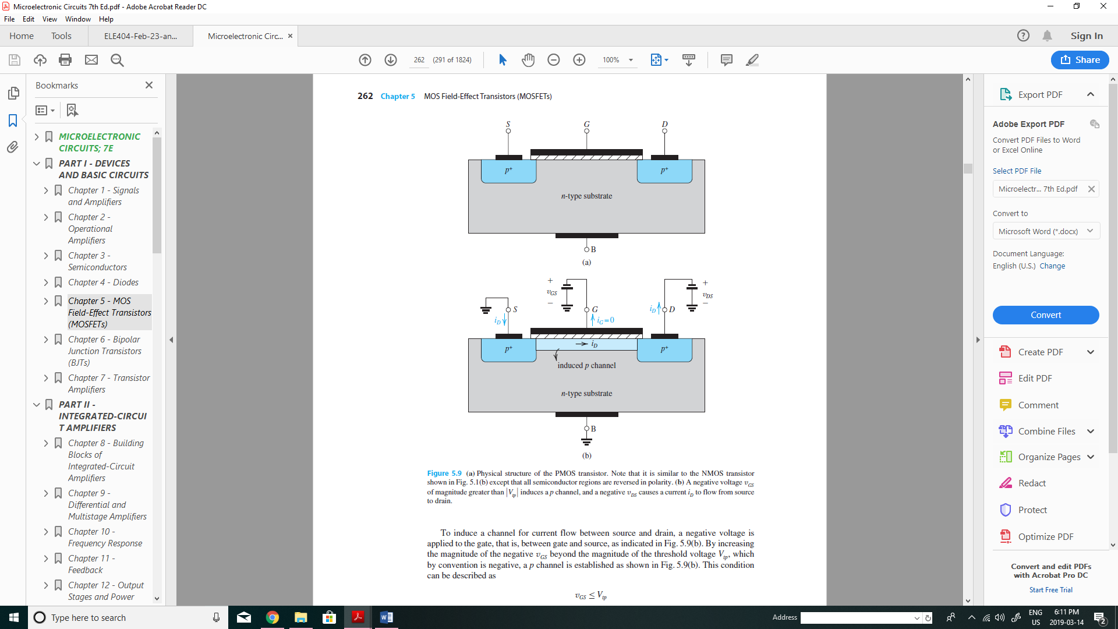

Figure: Physical structure of a PMOS device

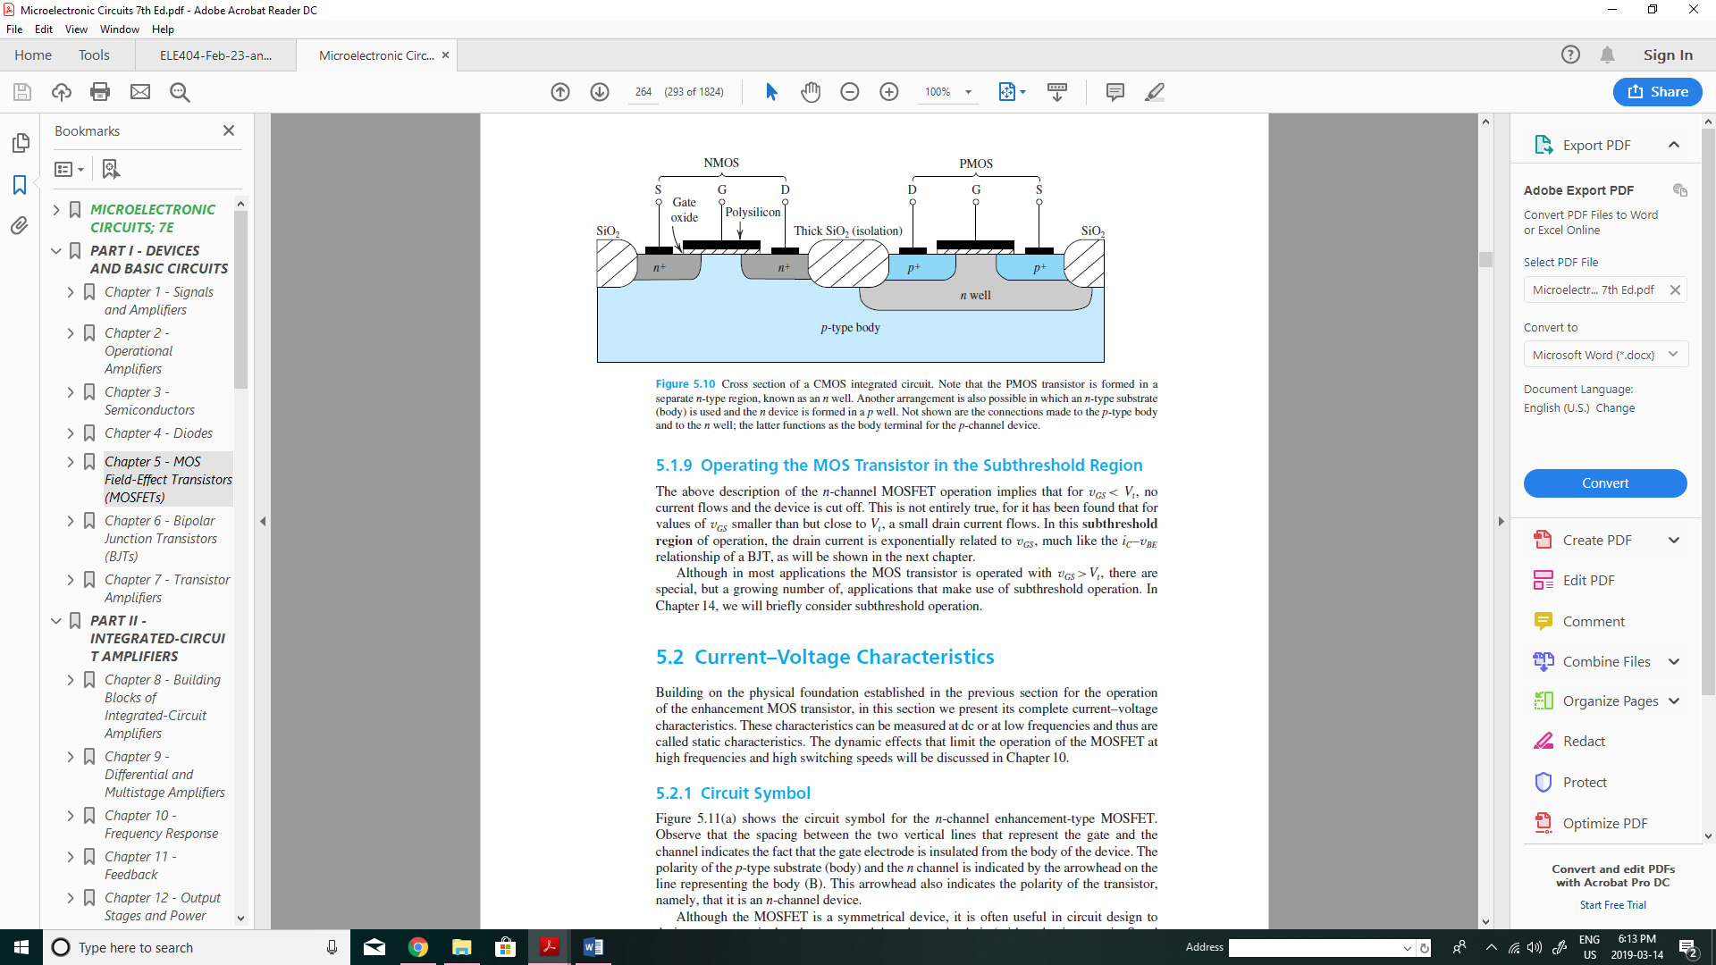

Figure: Physical structure of a Complementary MOS (CMOS) device

Circuit Symbols:

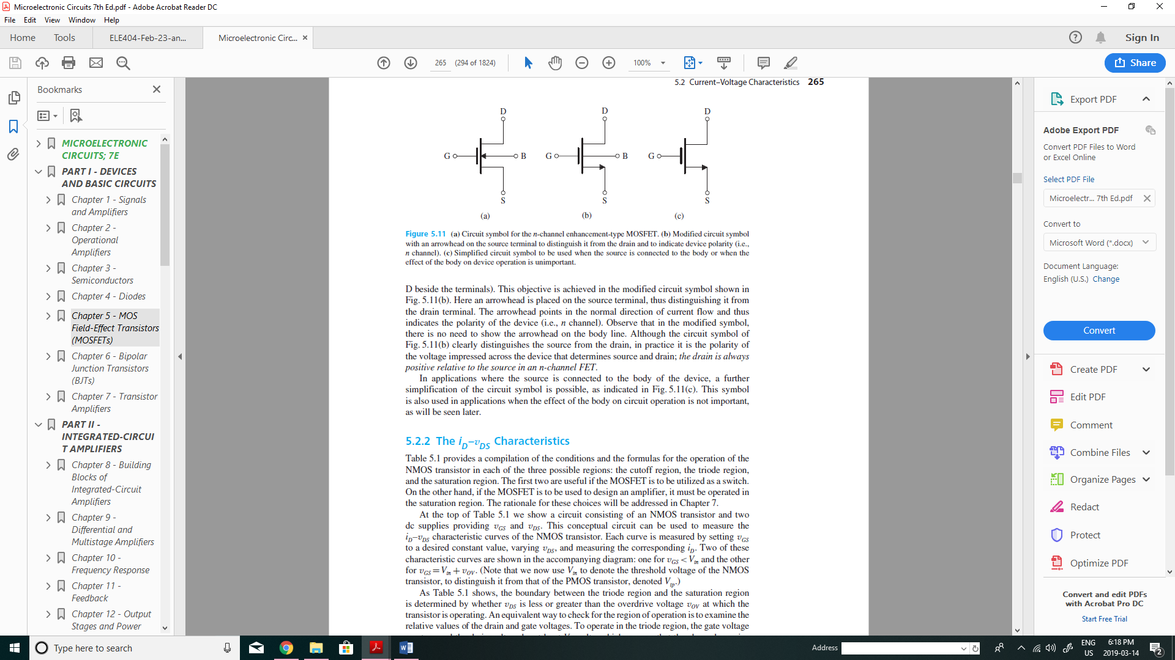

In an NMOS device, the substrate (Body) must be tied to the lowest voltage present in the circuit. If, however, only one device is involved, then the Body can alternatively be connected to the source.

On the other hand, the substrate (Body) of a PMOS device must be connected to the largest voltage present in the circuit. Again, if only one device is involved, then the Body can alternatively be connected to the source.

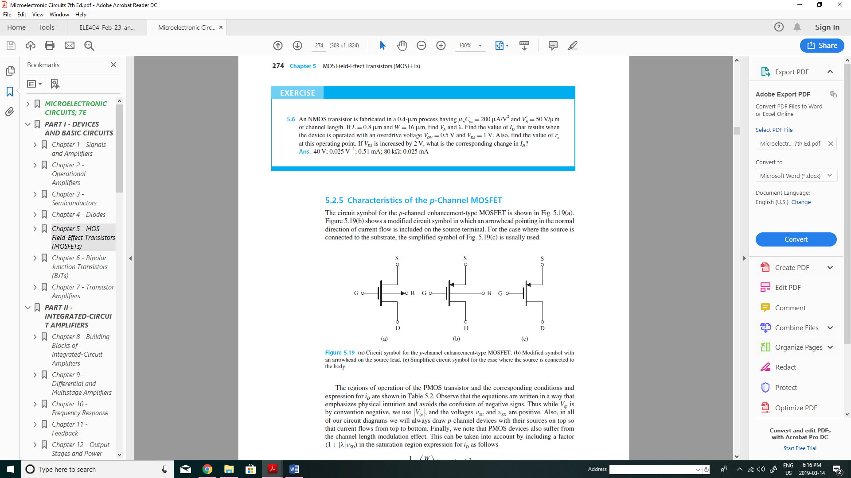

Important Voltages and Currents:

MOSFET is controlled (i.e. its current can be varied) by means of $v_{GS}$ ($v_{SG}$ in the PMOS device) and $v_{DS}$ ($v_{SD}$ in the PMOS device). A very important feature of a MOS device is that its Gate current (counterpart to the Base current in the BJT) is zero, rendering the source and drain currents equal.

Important Parameters: 

$t_{ox:}$ Oxide thickness [m]

$ε_{ox}$: Permittivity of oxide [F/m]

$C_{ox}=\frac{ε_{ox}}{t_{ox}}:$ Oxide Capacitance per unit gate area [F/m2]

W: Channel width [m]

L: Channel length [m]

The minimum of L represents the state-of-the art. The 30nm-technology means the minimum channel length L=30nm.

WL: gate area [m2]

: aspect ratio

It is an important design parameter as it will become increasingly apparent in this course.

$μ:$ mobility [m/(V.s)]

$μ_{n}:$ mobility of electrons

$μ_{p}$: mobility of holes

$k^{'}=μC_{ox}$: Process transconductance parameter [A/V2]

: MOSFET transconductance parameter [A/V2]

: Threshold voltage [V]

$V_{tn}$: threshold voltage for an NMOS device (is positive)

$V_{tp}$: threshold voltage for a PMOS device (is negative)

(with the state-of-art, its value ranges from 0.3V to 1.0V. Smaller values are preferred for obvious reasons.)

$v_{ov}$: Overdrive voltage (or effective voltage)

$v_{ov}≜v_{GS}-V_{tn}$: the value by which $v_{GS}$ exceeds $V_{tn}$ in an NMOS device. It is positive. $v_{GS}=v_{ov}+V_{tn}$

$v_{ov}≜v_{SG}-\left|V_{tp}\right|$: the value by which $v_{SG}$ exceeds $V_{tp}$ in a PMOS device. It is positive. $v_{SG}=v_{ov}+\left|V_{tp}\right|$

Modes of Operation:

Consider the following test circuit, by which a MOS device can be characterized. Thus, $v_{GS}$ and $v_{DS}$ are varied and the Drain current, $i_{D}$, is observed. The result is the family of the curves shown below which identify three distinct mode of operation: the cut-off mode, the triode mode, and the saturation mode.





Cut-off mode of operation

If $v_{GS}<V_{tn}$ ( $v_{GS}<\left|V_{tp}\right|$ in a PMOS device), then the transistor is off and $i_{D}=0$ (hence, $i_{S}=0$).

Triode mode of operation (analogous to saturation mode in BJT)

If $v_{GS}<V_{tn}$ and $v_{DS}≤v_{GS}-V_{tn}$ (or $v_{DS}≤v_{ov}$), then,

$i_{D}=k_{n}\left[\left(v_{GS}-V_{tn}\right)-\frac{1}{2}v_{DS}\right]v_{DS}$,

where $k_{n}=k_{n}^{'}\left(\frac{W}{L}\right)$.

The requirement $v_{DS}≤v_{GS}-V_{tn}$ can also be written as

$$v_{D}-v_{S}≤v_{G}-v_{S}-V_{tn}$$

$$v_{D}≤v_{G}-V_{tn}$$

$$V_{tn}≤v_{G}-v_{D}≤v_{GD}$$

For a PMOS device, the foregoing relationships read as follows:

If $v_{SG}>\left|V_{tp}\right|$ and $v_{SD}≤V_{SG}-\left|V_{tp}\right|$ (or $v_{DG}≥\left|V_{tp}\right|$)

Then,

$$i_{D}=k_{p}\left[\left(v_{GS}-\left|V_{tp}\right|\right)-\frac{1}{2}v_{SD}\right]v_{SD}$$

$$i_{D}=\frac{1}{2}k_{n}\left[2\left(v_{GS}-V_{tn}\right)-v_{DS}\right]v_{DS}$$

$i_{D}≈\frac{1}{2}k_{n}\left[2v_{ov}\right]v_{DS}$ [if ${2v}_{ov}≫v_{DS}$, as $v_{GS}-V_{tn}=v_{ov}$]

$$i_{D}≈\left(k_{n}v_{ov}\right)v_{DS}$$

That is, in the triode mode, if $v_{Ds}$ is small, $i_{D}$ is almost linearly proportional to $v_{DS}$; the constant of proportionality equals $k_{n}\left(v_{GS}-V_{tn}\right)$ and can be controlled by $v_{GS}.$ This can also be observed in the $v_{DS}-i_{D}$ characteristic curve of the device around the origin.

$$r_{DS}≜\frac{v_{DS}}{i_{D}}=\frac{1}{k_{n}\left[v_{ov}-\frac{1}{2}v_{DS}\right]}$$

In general, the resistance, $r_{DS}$, is nonlinear since its value depends also on $v_{DS}$. However, if $v_{DS}$ is small ($≪2v_{ov}$), then the resistance is almost linear and with the value





Application of the triode mode:

There are numerous applications for an MOS in the triode mode. In fact, all twitched-mode circuits, whether of digital logic type or of power type, employ MOSFET that transition back and forth between the cut-off mode and the triode mode (saturation mode, if a BJT is used). In analog circuits, an MOS in the triode mode can be used as a voltage-controlled resistance to, for example, control the gain. For example, in the circuit shown below, the MOS is used to control the emitter degeneratio9n resistance of a CE amplifier and, thus, to control the gain.



Example #1

A PMOS device has the following parameters: $k_{p}=0.5mA/V^{2}$ and $V_{tp}=-1.0V$.

Find the node voltages and branch currents in the following circuit assuming the triode mode.



Exercise #1

Assume the triode mode and calculate $v_{o}$ in the following circuit. Assume the same parameters for the transistor as those for the device in Example #1.



Saturation mode of operation (analogous to the active mode in the BJT)

This mode of operation is used for building amplifiers and current sources, similar to the active mode in the BJT. In this mode, the drain current strongly depends on $v_{GS}$ ( $v_{SG}$ in a PMOS device) and also depends weakly on $v_{DS}$ ( $v_{SD}$ in a PMOS device).

In the saturation mode, we have

$v_{GS}>V_{tn}$ and $v_{DS}>v_{GS}-V_{tn}$ (or $v_{GD}<V_{tn}$)

Then,

$$i_{D}=\frac{1}{2}k_{n}v_{ov}^{2}\left(1+λv_{DS}\right)$$

Where $λ$ is called the channel-length modulation effect, unit is $V^{-1}$. The effect is similar to the Early effect in the BJ and, therefore, $λ$ can, alternatively be introduced as $\frac{1}{V_{A}}$ ( $V_{A}$ is the Early voltage).

Thus,

$$i_{D}=\frac{1}{2}k_{n}v_{ov}^{2}\left(1+\frac{v_{DS}}{V_{A}}\right)$$

The Early voltage $V_{A}$ is the product of a process-technology parameter, $V_{A}^{'}$, and the channel length, L.

$$V_{A}=V_{A}^{'}L$$

The channel-length modulation effect represents the fact that $i_{D}$ also depends upon $v_{DS}$; the dependence, however, is relatively weak as $V_{A}$ is a relatively large voltage, although not as large as in a BJT.

Moreover, NMOS devices have larger $V_{A}$ than PMOS. Furthermore, discrete devices have larger $V_{A}$ than Integrated Circuit (IC) chip.

Therefore, in MOS-based ICs the $V_{A}$ can not be ignored.

$$i_{D}=i_{D}^{'}\left(1+\frac{v_{DS}}{V_{A}}\right)$$

Where $i_{D}^{'}=\frac{1}{2}k_{n}v_{ov}^{2}$, is the current without Early effect.

$$i_{D}=i_{D}^{'}+1+\frac{v_{DS}}{\frac{V_{A}}{i_{D}^{'}}}$$

$$i_{D}=i_{D}^{'}+1+\frac{v_{DS}}{r_{o}}$$

Where, $r_{o}≜\frac{V_{A}}{i_{D}^{'}}$

Therefore, the circuit model of MOSFE in the saturation mode:





A PMOS device has the following parameters: $k_{p}=0.5mA/V^{2}$ and $V_{tp}=-1.0V$.

Find the node voltages and branch currents in the following circuit assuming the saturation mode. Ignore the channel-length modulation effect.

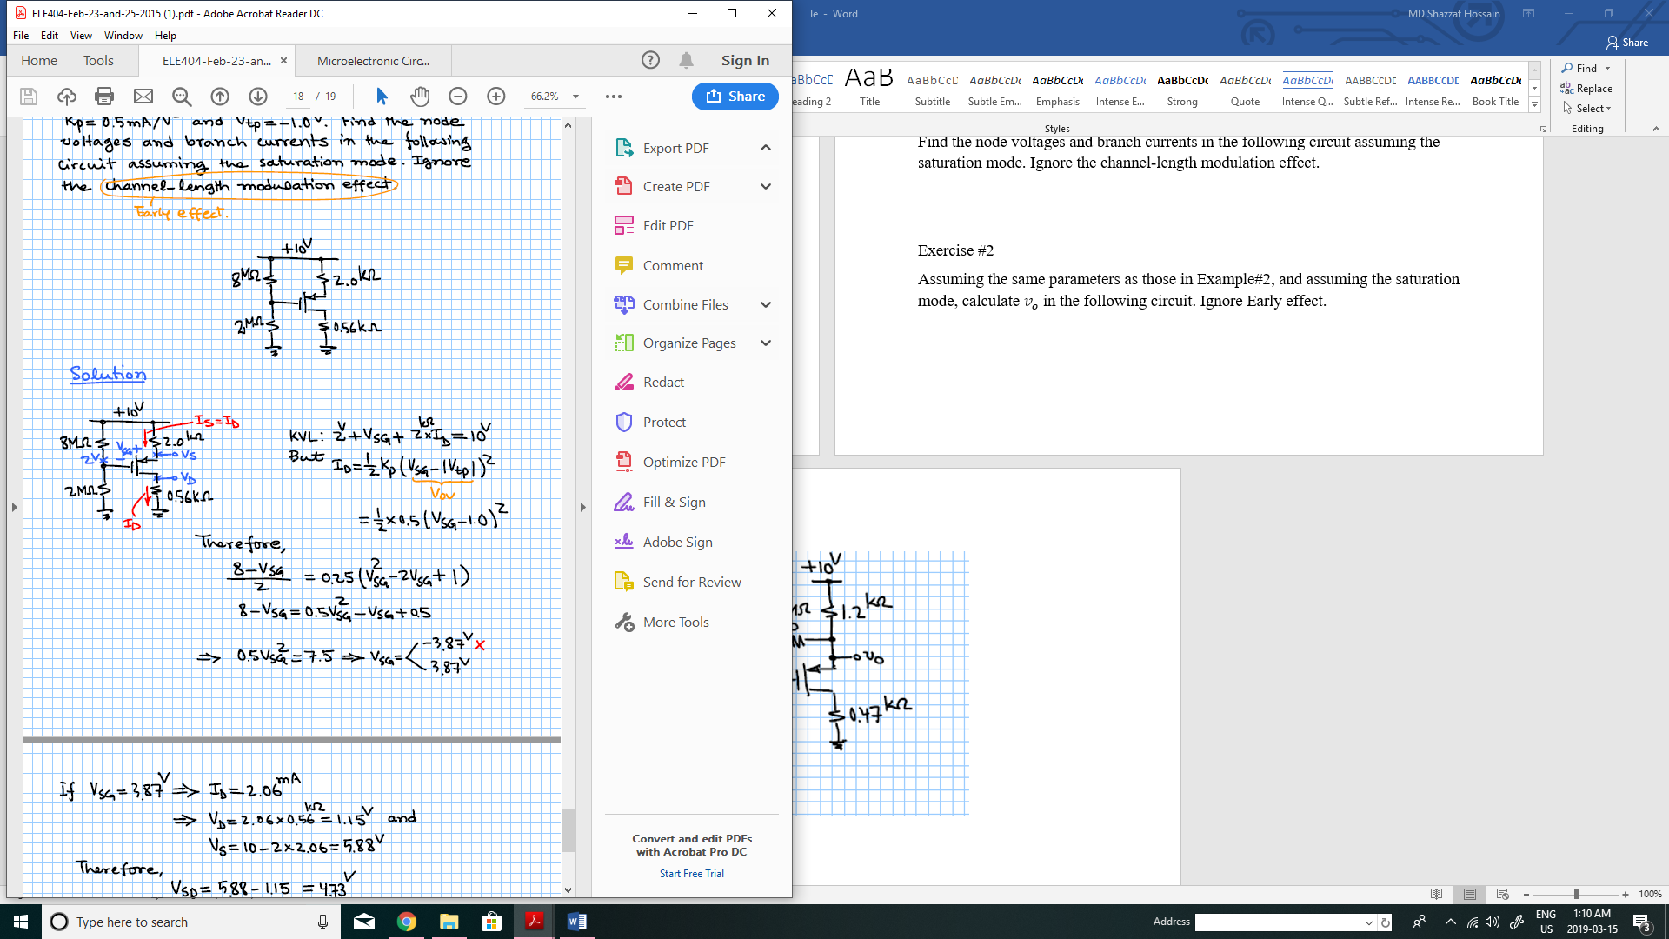

Exercise #2

Assuming the same parameters as those in Example#2, and assuming the saturation mode, calculate $v_{o}$ in the following circuit. Ignore Early effect.

